Uninformed Environmentalist
Name: Waldo Barns
Backstory: Waldo is a man that knows nothing, but thinks he knows everything. His ignorance and arrogance work against him. Waldo is also a passionate individual. His love for the environment extends far more than his love for his wife. His wife doesn’t understand his need to protect the environment, especially since he doesn’t know the first thing about environmental safety. But he presses on, and in the wake of a new nuclear energy plant, his devotion toward the environment has surfaced with a new level of intensity.
Hobbies/Activities: He works at Home Depot. He loves riding his motorcycle and petting his turtle, Arnold. He spends much of his free time watching Nascar while sipping a sweet tea.
Level of Education: High School – Graduated 1976
Knowledge of Nuclear Industry: None – He only knows that it produces electricity for our homes.
Effects of Nuclear Plant on them: Lives 10 miles away. None – no effect on Waldo.
How do they think it will affect them? He thinks it will cause radioactive breakouts, and destroy the environment down to every last blade of grass.
1-5 Scale: 5
Mode: Flyer to organize rally
Points:
- The radiation will implant itself into the environment which will cause plants to mutate.
- Radioactive waste will leak into the water systems, eventually poisoning the fish and humans.
- Eating plants and animals exposed to this radioactivity will cause diseases in humans.
- Pollution from cooling towers breaks down the ozone layer.

ENVIRONMENT WILL BE DESTROYED!!!!!!!!!
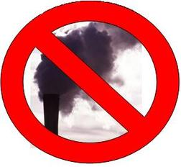
NEW NUCLEAR PLANT WILL DESTROY OUR COMMUNITY!!!!
WITHOUT TREES NO LIFE!!!!!!
HELP SAVE ALL OF HUMANITY!!!!
*RALLY WILL BE HELD AT WASHINGTON FIREHALL*
Questions? Call Waldo Barns!

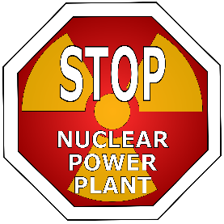
Danger, danger!!!!!!! A nuclear power plant is moving in next door, and we are all in jeopardy. This mechanical monster will ruin this community’s trees, gardens, even your new posies. The radiation will implant itself into the environment causing plants and animals to mutate (very bad). Not only will the radiation in the air harm things, so will the toxic, radioactive waste being dumped into the waterways. Another health concern is the pollution that is spewed from the menacing towers which is a threat to our ozone layer. And how do we know it isn’t poisoning us?! We don’t! It’s the government! Acid rain will also be another major side effect. It’s caused by pollution being stuck in the atmosphere. We will burn to death!!!! But if you come to this meeting, we will escape Hell!

